Lab 4: Exploring WSL—Ubuntu CLI Fundamentals and Command-Line Arguments in C

Theory
Windows Subsystem for Linux (WSL) allows a Linux distribution such as Ubuntu to run within the Windows operating system. It provides a Linux command-line environment for creating directories, managing files, editing programs, compiling source code, and executing applications. The basic WSL commands used in this lab are:
- pwd – displays the current working directory.
- cd – changes the current directory.
- mkdir – creates a new directory.
- ls – lists files and folders in a directory.
- nano – opens a text editor to create or edit files.
- gcc – compiles a C source file into an executable program.
- ./test – executes the compiled program named test.
- touch – creates an empty file.
- cp – copies files or directories.
- clear – clears the terminal screen.

Write a C program to demonstrate the use of command-line arguments by adding two numbers passed through the command line.
In C programming, command-line arguments allow users to pass data to a program when it is executed from the terminal. These arguments are received through the main() function using the following syntax:
int main(int argc, char *argv[])
- argc (argument count) stores the total number of command-line arguments passed to the program, including the program name.
- argv (argument vector) is an array of strings that stores the command-line arguments. In this program, argv[1] and argv[2] contain the two numbers entered by the user.
Additionally,
- atoi() is a library function that converts a string into an integer. It converts the values in argv[1] and argv[2] so that they can be added mathematically.

Write a C program to demonstrate the use of command-line arguments in Ubuntu WSL by creating, editing, compiling, and executing a C program using the Linux command-line interface.
Procedure:
Step 1: Open Ubuntu in Windows Subsystem for Linux (WSL).
Step 2: Display the current working directory using: pwd
Step 3: Navigate to the Home directory (if required): cd ~
Step 4: Create a new directory: mkdir test
Step 5: Move into the newly created directory: cd test
Step 6: Create a C source file: nano helloworld.c
Step 7: Write the C program that accepts and displays command-line arguments, then save the file.
Step 8: Compile the program using the GCC compiler: gcc helloworld.c -o helloworld
Step 9: Execute the compiled program with command-line arguments: ./helloworld
Step 10: Observe the output displaying the total number of arguments and their values.
Step 11: End the program.

Source Code:
#include<stdio.h>
#include<stdlib.h>

int main(int argc, char *argv[]){
int x=atoi(argv[1]);
int y=atoi(argv[2]);
printf("Sum = %d", x+y);
printf("\n");
return 0;
}

Screenshots
Creating a folder and .c file:
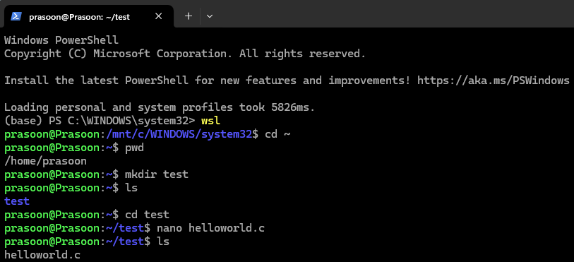
Writing program to add 2 numbers passed from CLI:
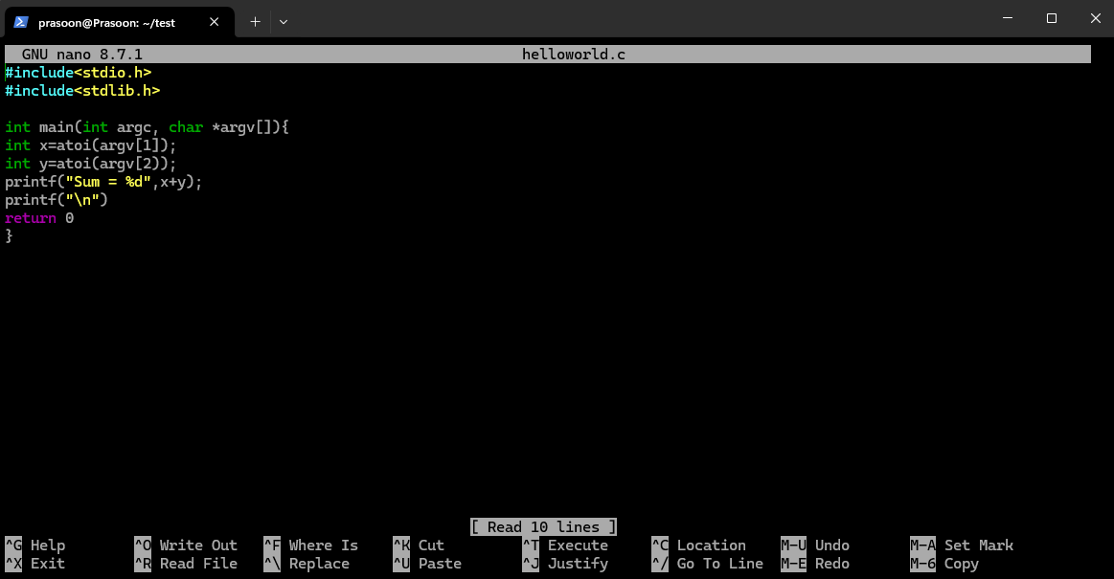
Compiling and running the file:
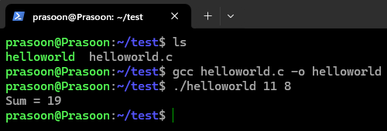

Conclusion
This experiment explored the Ubuntu command-line environment through WSL and demonstrated the creation, compilation, and execution of a C program. It provided practical experience with essential Linux commands for directory navigation and file management. The program successfully accepted numbers as command-line arguments and performed their addition after converting them into integer values. The experiment improved understanding of GCC compilation, program execution, and command-line input handling in C. Hence, the objectives of the experiment were successfully achieved.

